OOPS Concept:

* Object : Real World Entity
* Class: Template which decide how Object will be.
* Abstraction: Highlighting the important features from the user’s perspective without showing actual implementation
* Inheritance: Inheriting Parent feature into child
* Polymorphism: Ability of an object to behave differently in different situation.

Example Dog bark on stranger and shake his tail when see his owner.

Types

* + - Compile time Polymorphism- Method Overloading
    - Runtime Polymorphism-Method Overriding
* Diagram

  Description automatically generated
* 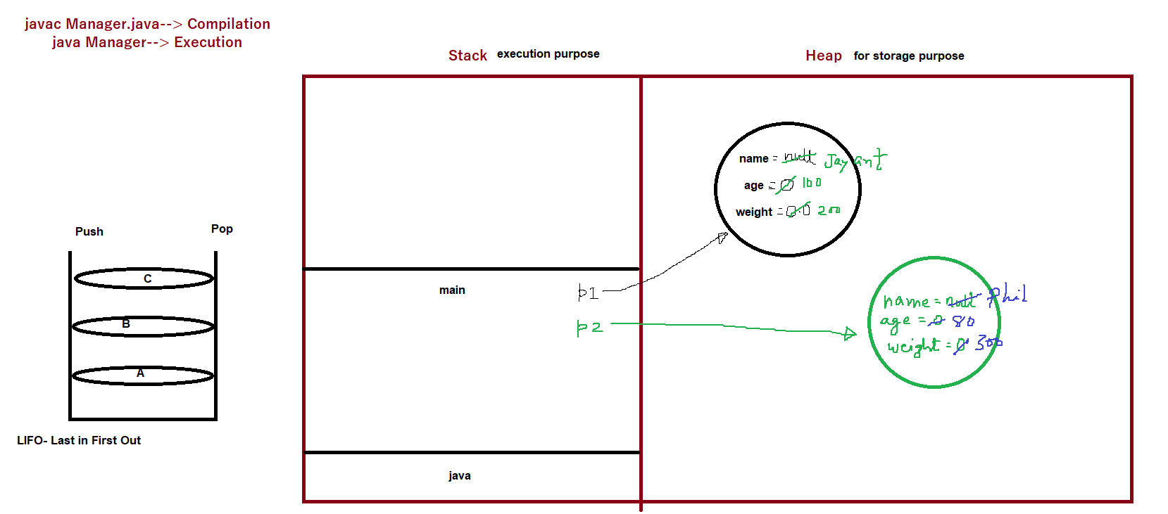
* 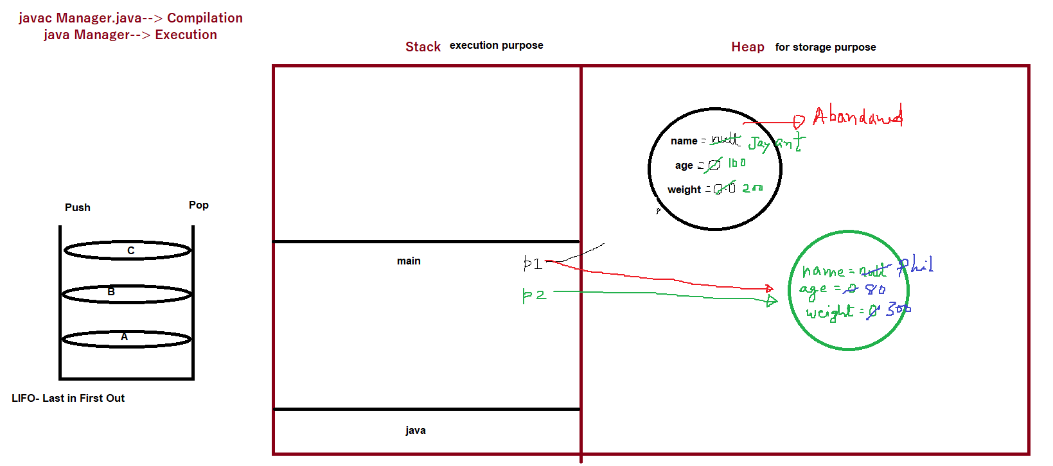

Summary:

Below are the important points we discussed

|  |
| --- |
| Object |
| Class |
| Abstracton |
| Encapsulation |
| Plolymorphism |
| Inheritence |
| Class name should start with uppercase |
| You can have max one public class inside a java file |
| Setting Environment variable |
| File name should be same as class name if class is declared as public |
| For every class one dot class file will get created. |
| package is used to keep files in organized manner, Its nothing but a folder/container of similar type of interface/classes |
| Java is Platform Independent |
| non static memebers cant be accessed inside static context directly- vice versa is not true |
| static member should not be accessed using reference variable(through object creation)  Garbage Collection- Abandoned Object  Object Creation  Memory Diagram |